AI Assisted Coding (III Year) Assignment
NAME : B. Rithwik
HT NO :2303A52330
BATCH :35

Lab 1: Exploring Additional AI Coding Tools beyond Copilot – Gemini (Colab)
and Cursor AI
Task1 -
Prompt: Write a Python function that takes a list of numbers and returns the mean, minimum, and maximum values. Also display the output.
Code :
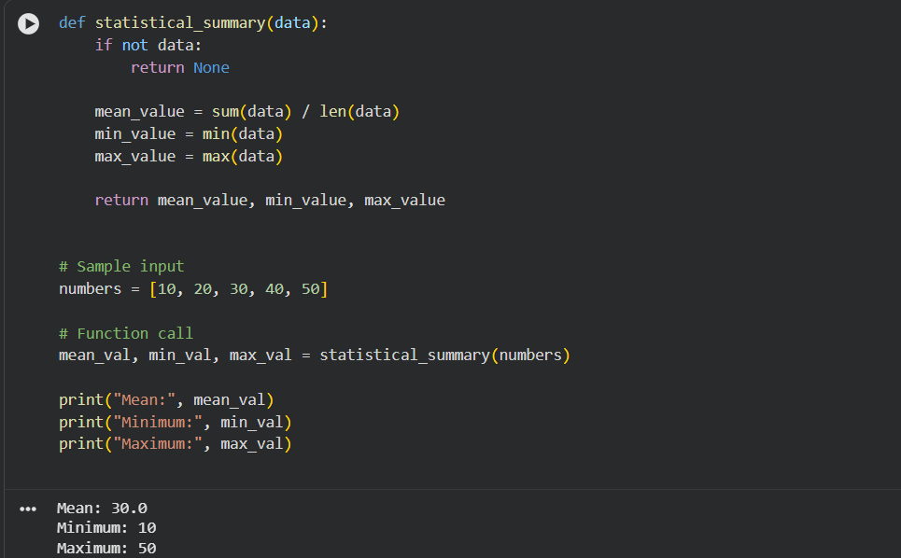

Explanation:
• Gemini generated correct and readable code
• Used built-in Python functions efficiently
• Suitable for beginners with minimal modification
Task 2: Armstrong Number – AI Comparison
Prompt: write a python program to reverse a string without using functions and optimize the code
Code 1:
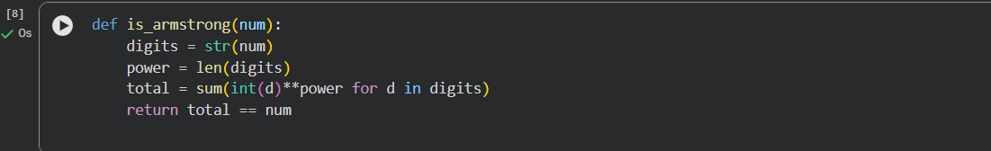
Code 2:
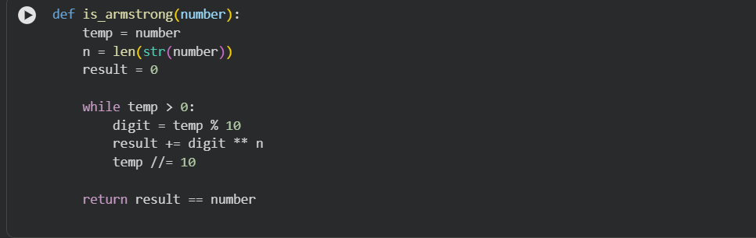
Explanation:
Gemini favors concise, modern Python. Copilot mirrors traditional logic taught in classrooms.
TASK-3
Prompt: Write a Python program to check if a year is a leap year
Code:
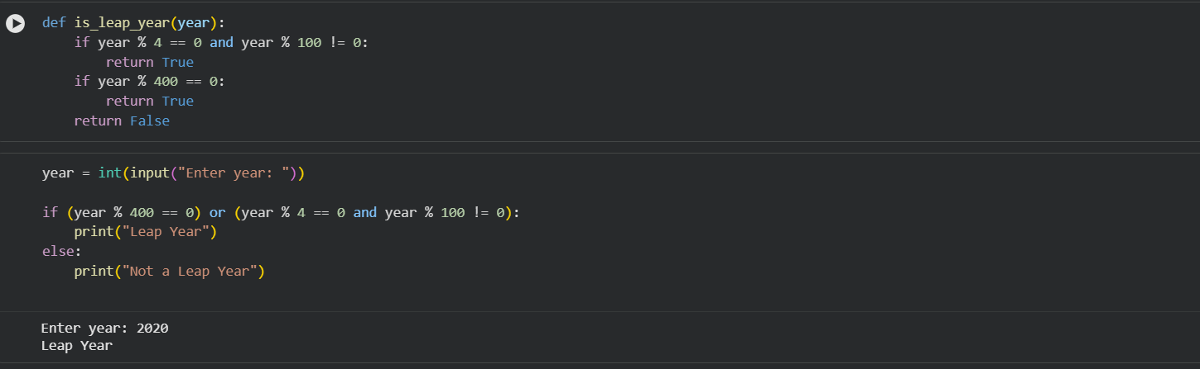

Explanation:
• Prompt 2 produced cleaner logic and user interaction
• Cursor adapts structure significantly based on prompt wording
• Demonstrates strong refactoring and formatting ability
TASK -4
Student Logic + AI Refactoring (Odd/Even Sum)
Code:

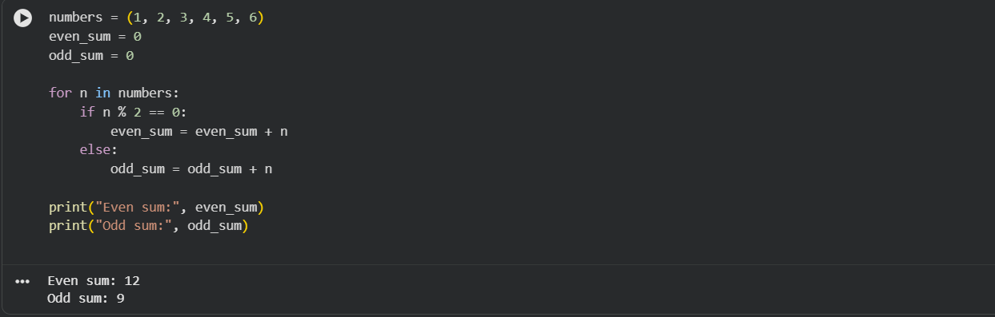

Explanation:
• Reduced code length
• Eliminated manual counters
• Used generator expressions
• Improved readability and maintainability

